SPRINT-2

TEAM ID: PNT2022TMID06411

PROJECT NAME: IoT based smart crop protection system for Agriculture

STEPS:

The random sensor data’s are generated and automation has been implemented through the python code instead of using hardware to implement IOT based crop protection system. And the python code need to upload the data’s in IBM cloud are written in this python script.

CREATION OF IBM WATSON CLOUD PLATFROM:
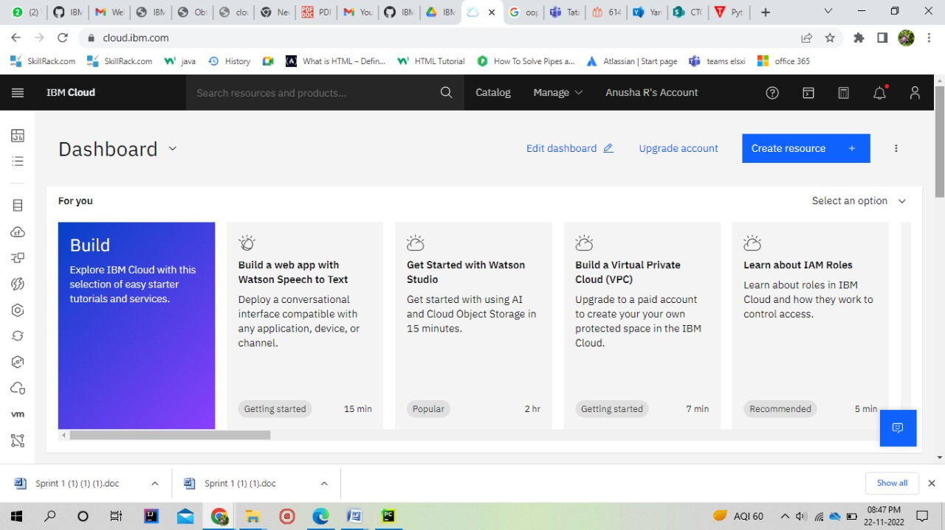

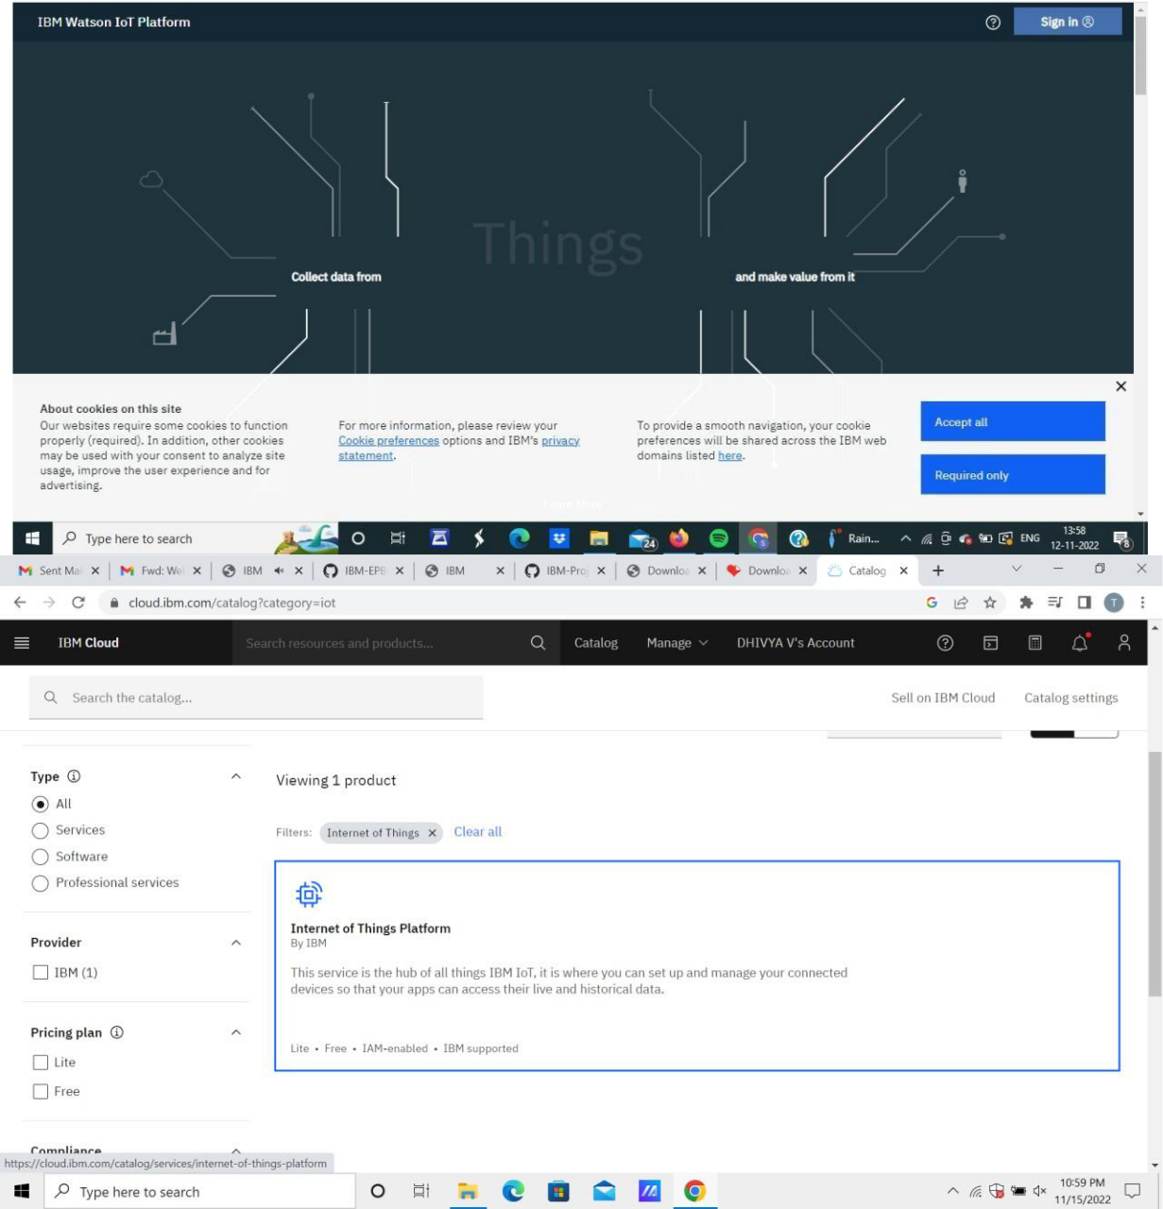

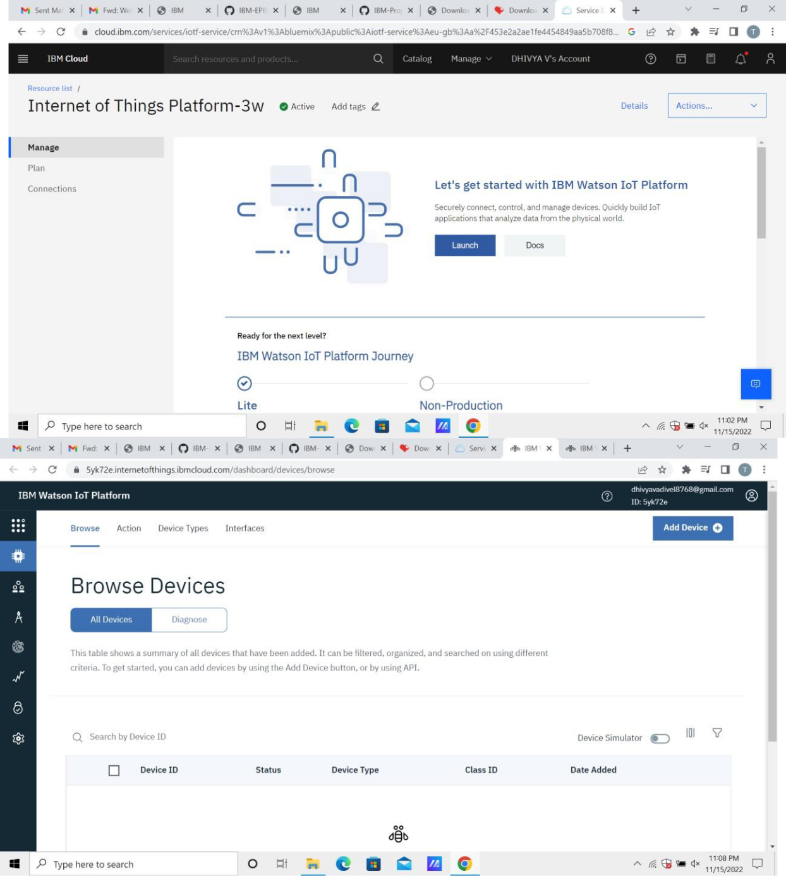

CODE:

import random

import ibmiotf.application

import ibmiotf.device

from time import sleep
import sys

#IBM Watson Device Credentials. organization = "3xaptt" deviceType = "NodeMCU" deviceId = "12345" authMethod = "use-token-auth" authToken = "12345678"

def myCommandCallback(cmd):

print("Command received: %s" % cmd.data['command']) status=cmd.data['command'] if status=="sprinkler_on":

print ("sprinkler is ON")

else :

print ("sprinkler is OFF")

#print(cmd)

try:

deviceOptions = {"org": organization, "type": deviceType, "id": deviceId, "auth-method": authMethod, "auth-token": authToken}

deviceCli = ibmiotf.device.Client(deviceOptions)

except Exception as e:
print("Caught exception connecting device: %s" % str(e))

sys.exit()

#Connecting to IBM watson.

deviceCli.connect()

while True:

#Getting values from sensors.

temp_sensor = round( random.uniform(0,80),2)

PH_sensor = round(random.uniform(1,14),3)

camera = ["Detected","Not Detected","Not Detected","Not Detected","Not Detected","Not Detected",]

camera_reading = random.choice(camera)

flame = ["Detected","Not Detected","Not Detected","Not Detected","Not Detected","Not Detected",]

flame_reading = random.choice(flame)

moist_level = round(random.uniform(0,100),2)

water_level = round(random.uniform(0,30),2)

#storing the sensor data to send in json format to cloud.

temp_data = { 'Temperature' : temp_sensor }

PH_data = { 'PH Level' : PH_sensor }

camera_data = { 'Animal attack' : camera_reading}

flame_data = { 'Flame' : flame_reading }
moist_data = { 'Moisture Level' : moist_level}

water_data = { 'Water Level' : water_level}

- publishing Sensor data to IBM Watson for every 5-10 seconds.

success = deviceCli.publishEvent("Temperature sensor", "json", temp_data, qos=0)

sleep(1)

if success:

print (" ............................publish ok. ........................... ")

print ("Published Temperature = %s C" % temp_sensor, "to IBM Watson")

success = deviceCli.publishEvent("PH sensor", "json", PH_data, qos=0)

sleep(1)

if success:

print ("Published PH Level = %s" % PH_sensor, "to IBM Watson")

success = deviceCli.publishEvent("camera", "json", camera_data, qos=0)

sleep(1)

if success:
print ("Published Animal attack %s " % camera_reading, "to IBM Watson")

success = deviceCli.publishEvent("Flame sensor", "json", flame_data, qos=0)

sleep(1)

if success:

print ("Published Flame %s " % flame_reading, "to IBM Watson")

success = deviceCli.publishEvent("Moisture sensor", "json", moist_data, qos=0)

sleep(1)

if success:

print ("Published Moisture Level = %s " % moist_level, "to IBM Watson")

success = deviceCli.publishEvent("Water sensor", "json", water_data, qos=0)

sleep(1)

if success:

print ("Published Water Level = %s cm" % water_level, "to IBM Watson")

print ("")

#Automation to control sprinklers by present temperature an to send alert message to IBM Watson.

if (temp_sensor > 35):

print("sprinkler-1 is ON")

success = deviceCli.publishEvent("Alert1", "json",{ 'alert1' : "Temperature(%s) is high, sprinkerlers are turned ON" %temp_sensor }

- qos=0)

sleep(1)

if success:

print( 'Published alert1 : ', "Temperature(%s) is high, sprinkerlers are turned ON" %temp_sensor,"to IBM Watson")

print("")

else:

print("sprinkler-1 is OFF")

print("")

#To send alert message if farmer uses the unsafe fertilizer to crops.

if (PH_sensor > 7.5 or PH_sensor < 5.5):

success = deviceCli.publishEvent("Alert2", "json",{ 'alert2'

- "Fertilizer PH level(%s) is not safe,use other fertilizer" %PH_sensor } ,

qos=0)
sleep(1)

if success:

print('Published alert2 : ' , "Fertilizer PH level(%s) is not safe,use other fertilizer" %PH_sensor,"to IBM Watson")

print ("")

# To send alert message to farmer that animal attack on crops.

if (camera_reading == "Detected"):

success = deviceCli.publishEvent("Alert3", "json", { 'alert3' : "Animal attack on crops detected" }, qos=0)

sleep(1)

if success:

print('Published alert3 : ' , "Animal attack on crops detected","to IBM Watson","to IBM Watson")

print("")

#To send alert message if flame detected on crop land and turn ON the splinkers to take immediate action.

if (flame_reading == "Detected"):

print("sprinkler-2 is ON")

success = deviceCli.publishEvent("Alert4", "json", { 'alert4'

- "Flame is detected crops are in danger,sprinklers turned ON" }, qos=0)
sleep(1)

if success:

print( 'Published alert4 : ' , "Flame is detected crops are in danger,sprinklers turned ON","to IBM Watson")

print("")

else:

print("sprinkler-2 is OFF")

print("")

#To send alert message if Moisture level is LOW and to Turn ON Motor-1 for irrigation.

if (moist_level < 20):

print("Motor-1 is ON")

success = deviceCli.publishEvent("Alert5", "json", { 'alert5'

- "Moisture level(%s) is low, Irrigation started" %moist_level }, qos=0)

sleep(1)

if success:

print('Published alert5 : ' , "Moisture level(%s) is low, Irrigation started" %moist_level,"to IBM Watson" )

print("")

else:

print("Motor-1 is OFF")

print("")
#To send alert message if Water level is HIGH and to Turn ON Motor-2 to take water out.

if (water_level > 20):

print("Motor-2 is ON")

success = deviceCli.publishEvent("Alert6", "json", { 'alert6'

- "Water level(%s) is high, so motor is ON to take water out " %water_level }, qos=0)

sleep(1)

if success:

print('Published alert6 : ' , "water level(%s) is high, so motor is ON to take water out " %water_level,"to IBM Watson" )

print("")

else:

print("Motor-2 of OFF")

print("")

#command recived by farmer deviceCli.commandCallback = myCommandCallback

- Disconnect the device and application from the cloud deviceCli.disconnect()
OUTPUT
